Experiment 8
Analysis of the Effect of Conductor Width and Conductor Material on Transmission Line Characteristics
Test case 1:
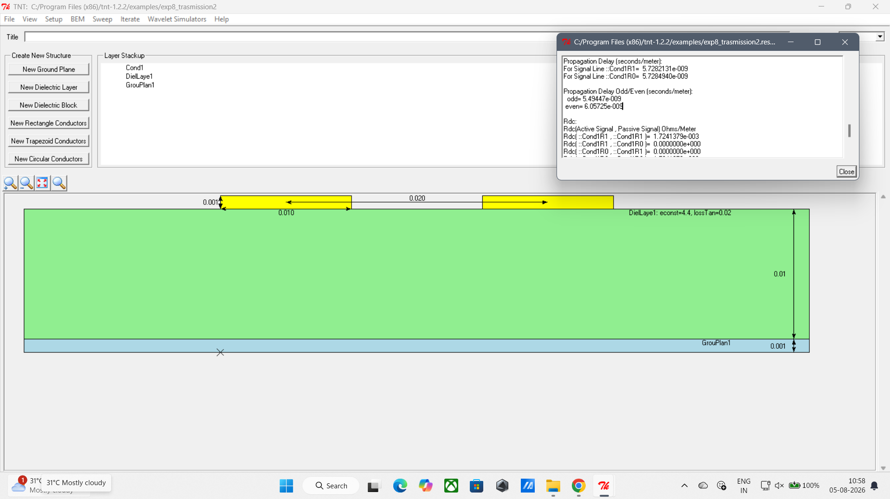
Test case 2 :
